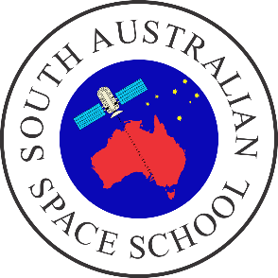**South Australian Space School – Teacher FAQ**

**The Centre for Australian Space Education (CASE) invites applications from Year 10 students for the 4-day annual residential South Australian Space School (SASS).**

ONLINE APPLICATIONS [www.spaceschool.com](http://www.spaceschool.com)

Please note **applications close date when applying. Details on** [**website**](http://www.spaceschool.com)**.**Students at the South Australian Space School will be accommodated at the Warradale Urban Camp School.  
  
Successful applicants will:

* + Take part in science investigations including building and launching model rockets at Hamilton Secondary College Space School
  + Undertake tours of the Adelaide University Moon lab.Visit the Defence Science & Technology Group
  + Hear inspiring talks about careers in space science, physics, engineering, life sciences and learn about the Australian Space Agency based in Adelaide.
  + Visit the Australian Space Agency Discovery Centre
  + Visit the RAAF Base at Edinburgh and be escorted through various testing facilities and aircraft (subject to RAAF availability)
  + Visit the Planetarium at Hamilton Secondary College
  + Visit PIPEHENGE at Hamilton Secondary College

SASS will be supervised by female and male South Australian science teachers and scientists/engineers who have working with children checks and will reside with the students at Warradale.

**A registration fee of approximately $80 includes all meals and transport during SASS, printed materials, SASS windcheater, folder, and three nights accommodation. This fee is often paid for by the school.**

Defence Science and Technology Group (DSTG) sponsors a scholarship to enable rural and remote students to attend the Space School.

A maximum of 24 students will be selected for each camp. It is expected that equal numbers of males and females will attend.

Applicants must be students in Year 10 when attending SASS.